Get the most out of Studying
Tell me, what is “Study”? When you write study on your schedule what are you going to do? What are you studying? How do you know when you have achieved “Study”?
Setting the purpose of what your studying will save you time and allow you to get more done.
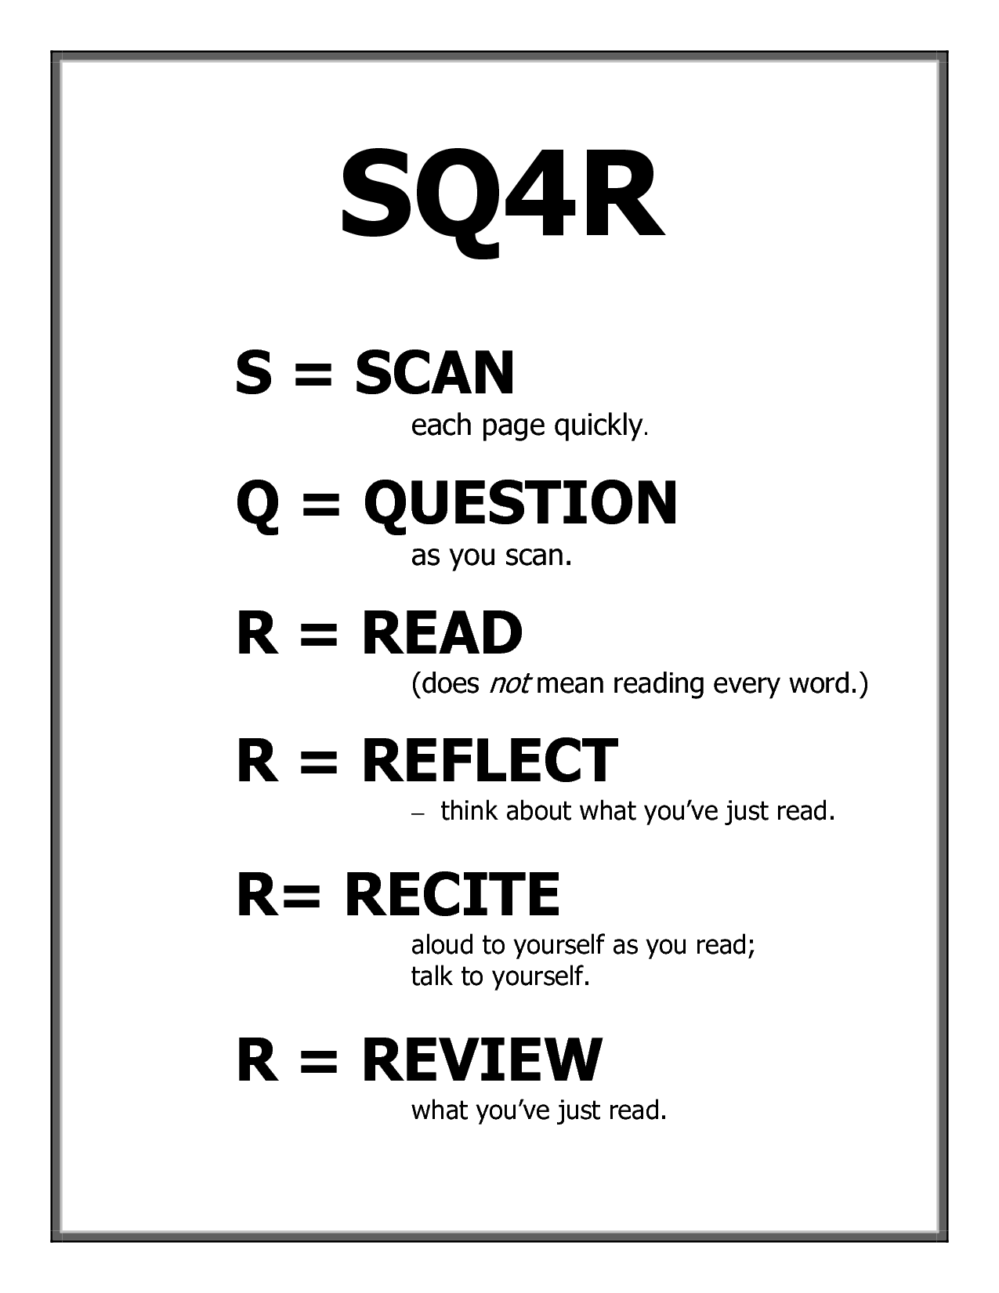
Determine the type of studying you will be doing
- Pre Reading: Reading information
before class. The purpose of pre-reading
is to be able to know the terms to be
used in class and gain a basic
understanding of what is being taught.
Practice SQ4R

            - Studying to Learn: This is when you read the chapter in full, sit in your lecture. You will understand the concepts and know how the concepts work. You may not remember everything at this point. But you will not have questions about the basic functions.
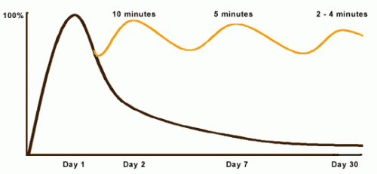

            - Reviewing: This should be done often. Spend your time reviewing the items that you don’t know very well. If you only studying the information once by the time you take your exam you will only remember 2-3% of what you have studied. Just 10 minutes a day can increase your memory of the material to 80-90%
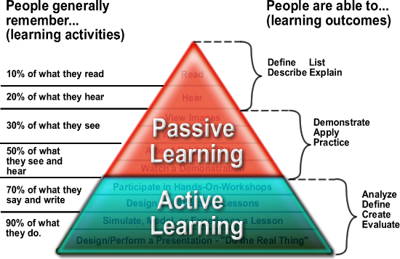
- Recall: Recall is a form of active learning. Active learning is placing the responsibility of learning on you. You need to; Think about, talk about, practice, quiz yourself. Reading your notes is not enough.

