Your Brain Works
HOW YOUR BRAIN WORKS
Remember the days when your brain absorbed information like a sponge? Well those days are long gone.
Children take information at face value. Rarely do they question why it matters.
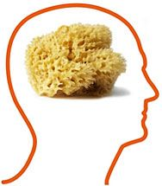
Santa Clause, Tooth Fairy
If you eat chewing gum you will die…
Your brain had been filled with thousands of neurons which worked to turn short term memories into long term memories
Your brain has developed in to an adult person’s brain. You are capable of critical thinking. Now you just need to learn to use your adult brain
No longer do you just take in information. Your brain has trimmed the neurons which absorb the information and has started working to organize the information
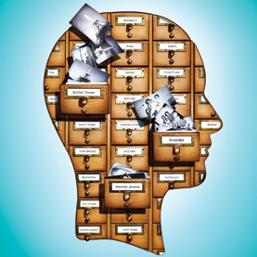
Your brain has to know how to take the information out too. RECALL is necessary to be able to use the information.
Your brain is taking time to organize so you can only take in a little at a time. You need short frequent breaks to process what you are learning. (See pamphlet on Good Study Breaks)

Now you have thousands of filing clerks storing away the information
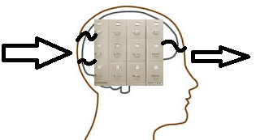
Have you ever not been able to remember information for a test? But once you look at your text book you remember everything? That’s because your brain has the information it just did not know where you stored it.
“To assume makes an Ass out of U and Me” – Example of how to actively recall information
Like checking a book out in the library the first time you look for it, it takes a while to find. Once you know where it is you just walk right to it.
Less neurons are taking information in. Your brain is spending its energy categorizing information. Connecting what you are learning to your life, other classes or anything that helps the brain know how to organize the information

