**Stress, Studying, Anxiety, and You**

Exams need to be studied for. There is no getting around that. But, the stress that comes from the studying should not be a constant part of the studying experience

*Stress is a* ***necessary*** *part of life. It is the driving force to* ***help us get stuff done****. But when the stress becomes ongoing, does not lessen with time, and can grow steadily worse, that stress has become anxiety.*



**Perfect amount of Stress**

**Ways to De-Stress**

* Positive self-talk: One of the biggest factors of too much stress is our own critical inner voice. Instead of asking “What if I fail?” ask “What if I do great!” Practice telling yourself
  + I am capable
  + I am in control and will learn this
  + I know more today than I did yesterday
* Deep Breathing (Do for at least 30 seconds to 10 minutes)
  + Slow deep breath in through your nose, hold it for a second, then slowly release it through your mouth
* Progressive muscle relaxation (Deep breathe while doing this)
  + Starting at your head isolate and tighten different groups of muscles working your way to your feet. Tighten as your breathe in and release the tension as you breathe out
* Meditation (Deep breathing)
  + Sit quietly for a period of time. Focusing on your breathing.
  + The idea is to not think about other things. Yes you will have thoughts flow through your mind but just let them go. Knowing that at that moment you do not need to worry about them.

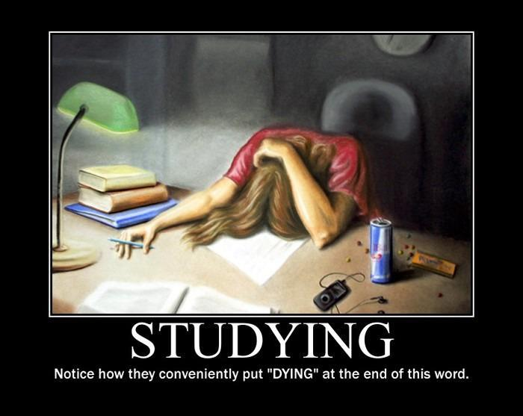

**Too Much Stress**



**Not Enough Stress**

*When you are stressed your brain does not retain what you are reading.*

*Taking a* ***productive*** *and* ***relaxing break*** *is the best way to be able to get back to studying (View Study Break pamphlet for more information on productive breaks)*

